Order Of Service

Singing: Psalm 6—CW page 66

Reading: Psalm 119:1-8

Opening Hymn: TLH 72

Reading: Hebrews 13:1-12

Request Hymn: CW Supplement 730

Reading: Luke 10:1-12

Sermon Hymn: TLH 87

Sermon Text: Acts 10:44-48

Peter Stays Certain Days

Prayer

The Apostles’ Creed, TLH page 12

Holy Communion

The Lord's Prayer

The Blessing

Closing Hymn: TLH 584

************
Bible Study: Lambs: Seals
Sheep: Deut. 16:1-8

Open Water
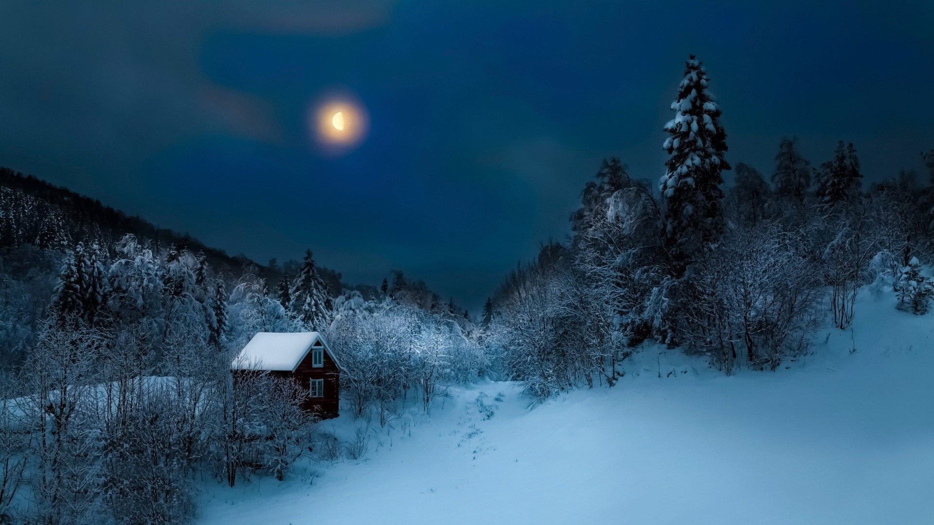

Winter Night

Water
Of
Life

22 December 2024

W A T E R O F L I F E

Independent Christian Church—Conservative Lutheran Doctrine

Worship Service: 9:30 a.m.

Larry Cooper, Pastor E-Mail address:
lcooper@wateroflife.cc
Web Site:
www.wateroflife.cc

* * * * * * * * * * * * * * * * * * * * * * * * * * *

Sermon Text: Acts 10:44-48

Peter Stays Certain Days

* * * * * * * * * * * * * * * * * * * * * * * * * * *

44 While Peter yet spake these words, the Holy Ghost fell on all them which heard the word.

45 And they of the circumcision which believed were astonished, as many as came with Peter, because that on the Gentiles also was poured out the gift of the Holy Ghost.

46 For they heard them speak with tongues, and magnify God. Then answered Peter,

47 Can any man forbid water, that these should not be baptized, which have received the Holy Ghost as well as we?
48 And he commanded them to be baptized in the name of the Lord. Then prayed they him to tarry certain days.

